

A Project

Report On

**Hotel Management System**

**By**

**HARUSHA S**

**BE**

**Batch:** 2021 – 5883

Under the Guidance of,

**Mamta Boga**

**Technical Trainer**

**EduBridge**

(School of coding)

**Introduction:**

This hotel management system is developed for hotels those are using a manual system to handle hotel processes. This system will automate the major operations of the hotel. There are two main users in hotel management system administrator and guests. Administrator can see about the employees and the hotel bookings.Administrator can also edit and delete the details of the employee and guest without any restrictions. The guests can view the hotel web site and can sign up and book the hotel room they want by using different type of payment methods.

**List of Modules**

* **Admin**
* **Guest**
* **Signup**
* **Room Booking**
* **Employee**
* **Check Out and Payments**

I have developed this Application in **Java, Springboot, Hibernate, and MySQL.** It’s a web-based project so I have used **HTML, CSS, JavaScript and Bootstrap also**.

The main feature of the project is to make hotel booking easier. You can access this website from anywhere and everywhere.

**Admin :**

Here,Admin can login and access booking detail and employee related information after that Admin will redirect to Admin dashboard here Admin have two modules :

* Booking List
* Employee List

In the booking list, admin can see different users booking the rooms and can perform CRUD operations like edit ,delete and update the list.

In the employee list admin can see all details of employees who are working in HBHR'S hotel and perform CRUD operations like edit, delete and update the list.

**Booking Form:**

The guests after signing up giving their details they are redirected to the booking form page where the guests can book the type of hotel rooms they need.

**Guest :**

The guests can open the hotel website and view the different pages of the hotel. The guests can see about the hotel by clicking the about us option and the guests can also view the attractions page and find different images of the hotel to get better idea of the hotel rooms and halls. The guests can sign up by clicking the sign up option from the home page or from the about us page. In sign up page the guests should give their details and then the booking page will open. The guests can select the type of rooms and book the hotel room. After that the payment page will be redirected to the guest with different payment options where the guests can do the payment by which the hotel gets booked. Also the guests can go to the feedback page in home and give their feedback so the hotel facilities can be updated.

**Aboutus :**

In about us page the users can read about the hotel details, services provided and the view of the hotel. It also redirects the user to the hotel booking page to sign up.

**Payment :**

To get the guest to book the hotel we use the payment option where the guest can use different payment methods like using cash to pay or cards by giving the costumer card details. After choosing the cash method or by doing using the card payment method the hotel gets booked for the guest and then he gets a pop up message that the hotel room is booked.

**Software Requirements:**

**Front end:** Java/J2EE technologies (SpringBoot Framework), HTML, CSS, JavaScript, Bootstrap, Hibernate.

**Back end**: MySQL workbench 8.0.23CE.

**Middleware/Server:** Apache Tomcat v7.0. IDE: Eclipse IDE for Java EE Developers

**Browser:** Best result on Google Chrome

**Operating System:** Window 10.

**Screenshots:-**

**Home Page:**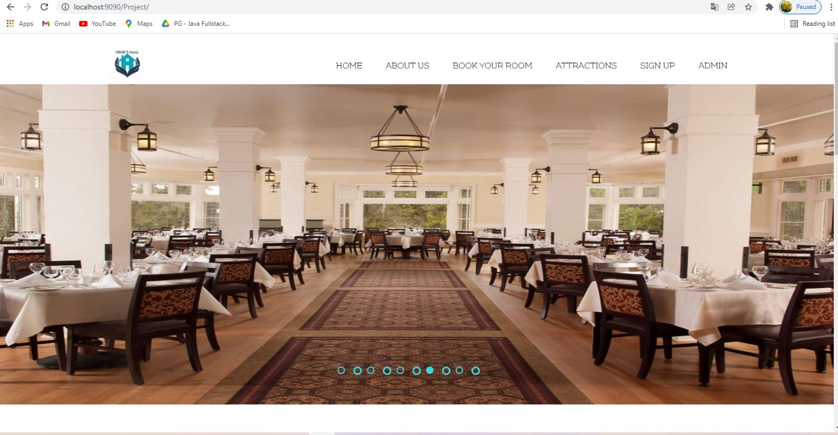

**Signup Page:**

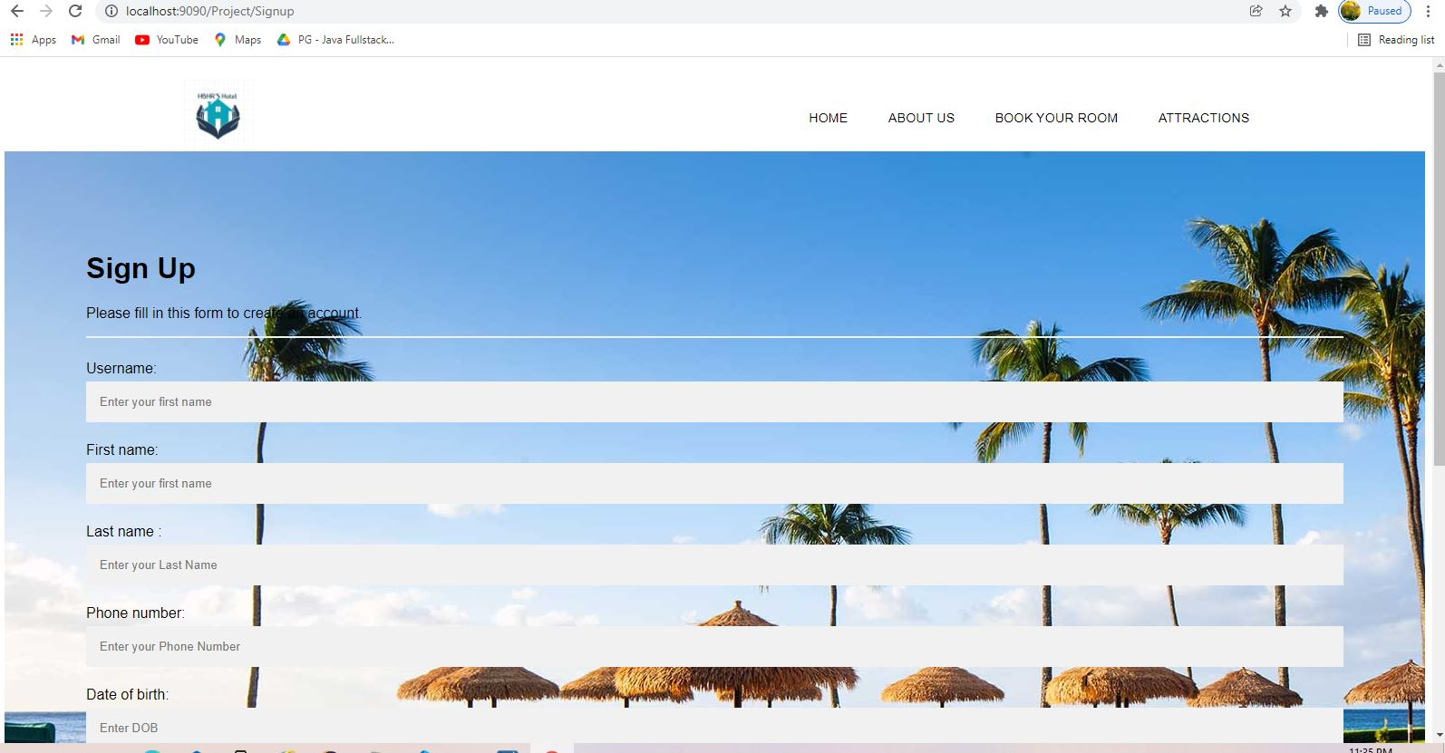

**Signup With Data:**

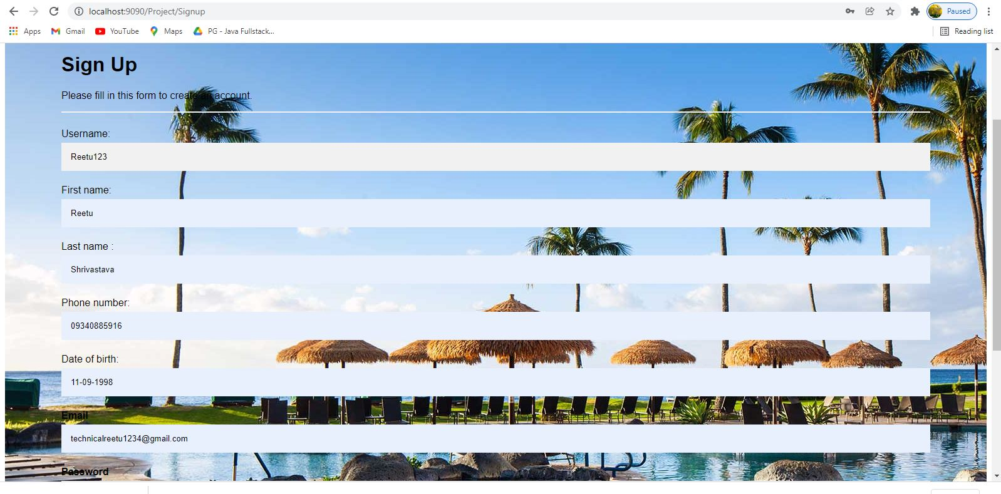

**Successful Signup Done**

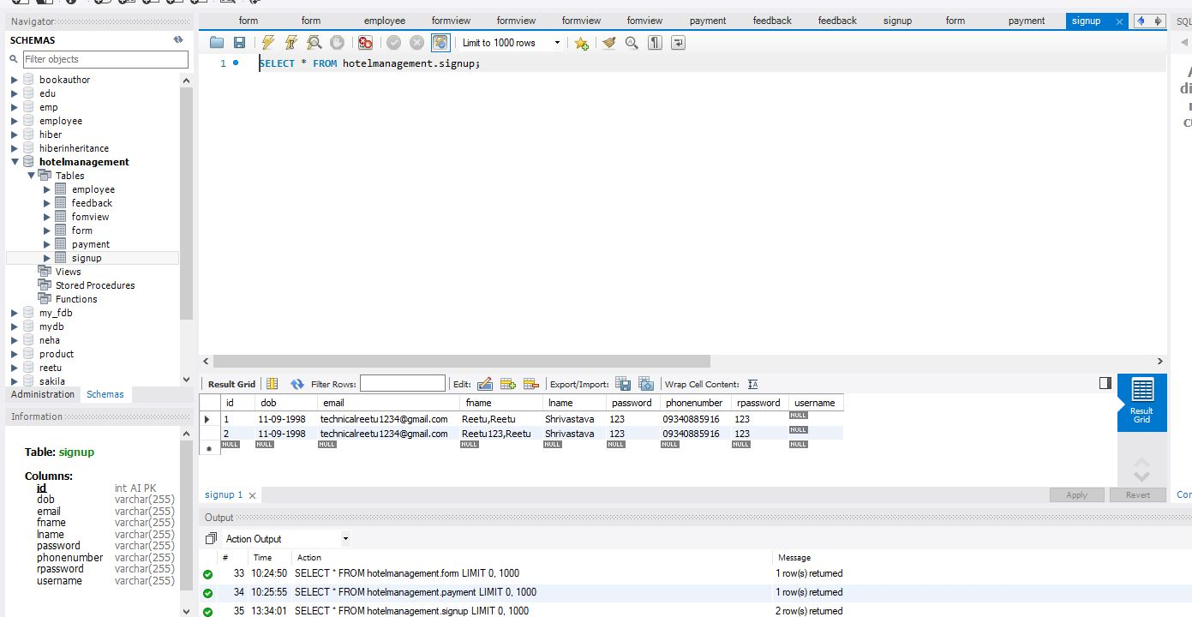

**Admin Page:**

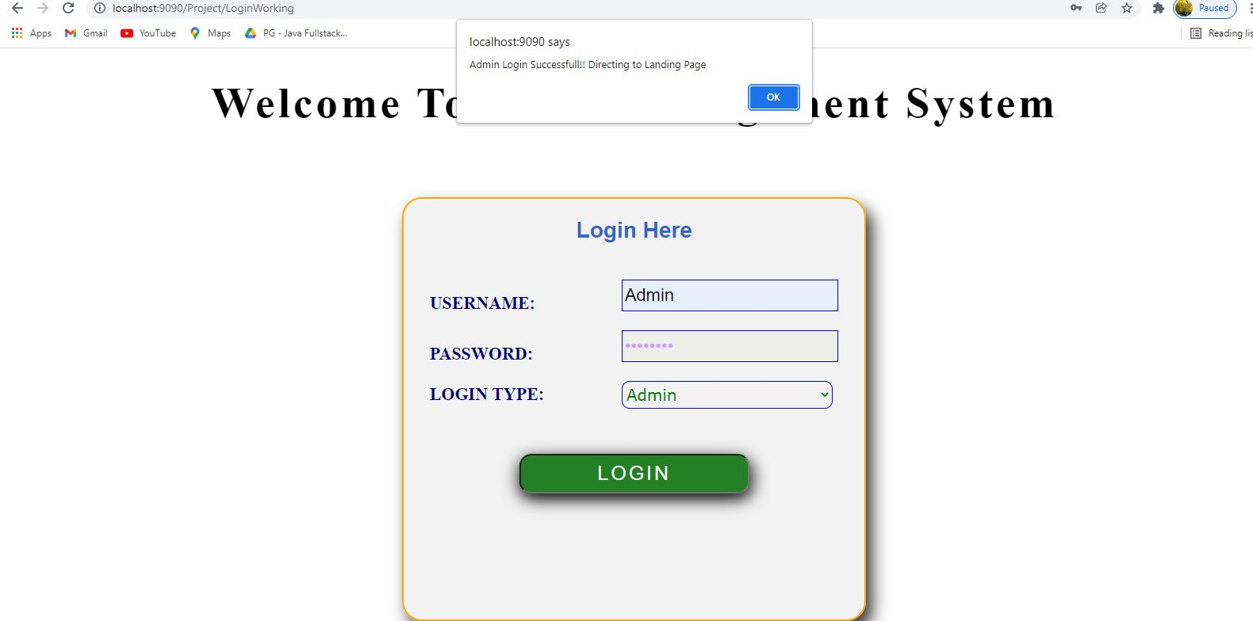

**Admin Dashboard Page:**

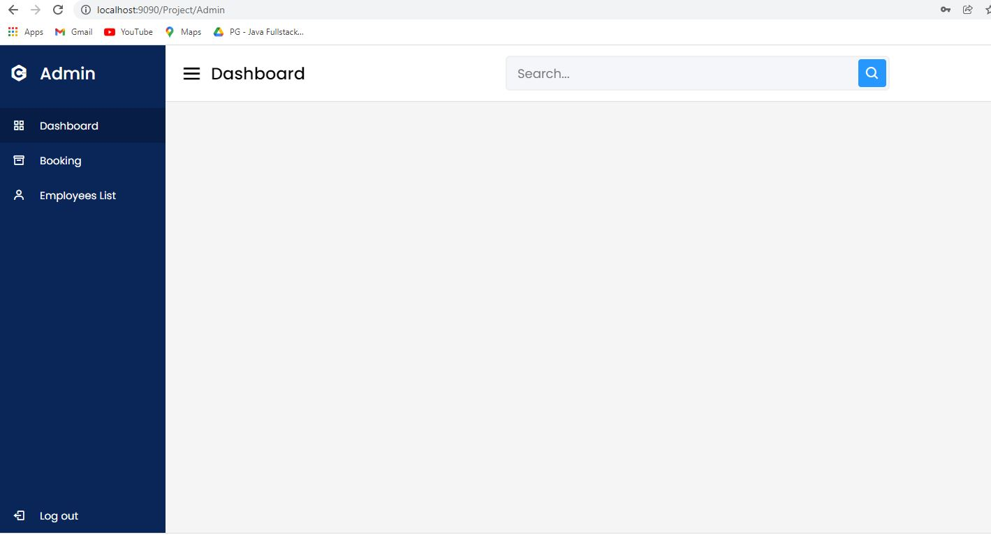

**User Booking Data by Admin :**

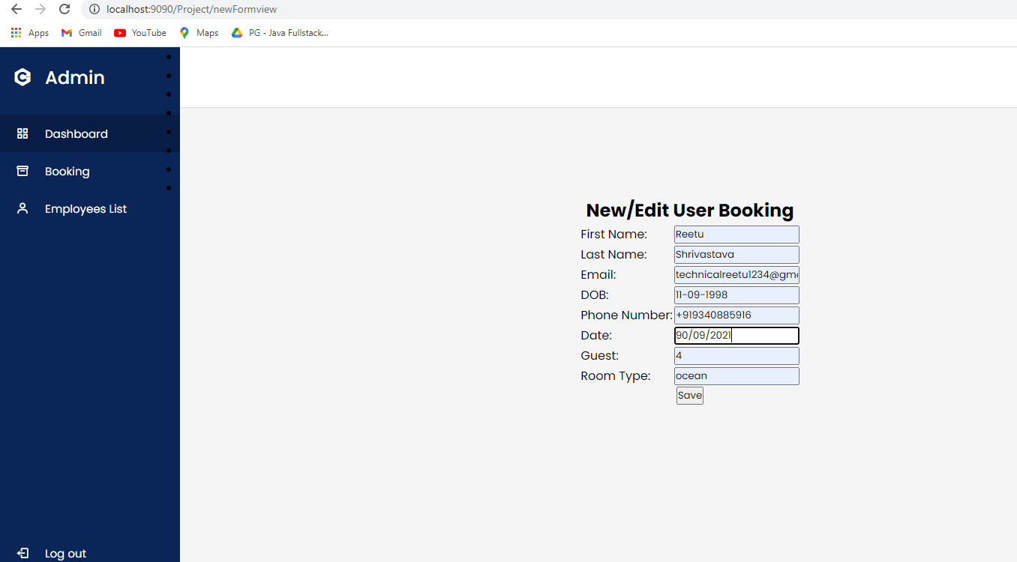

**Booking List :**

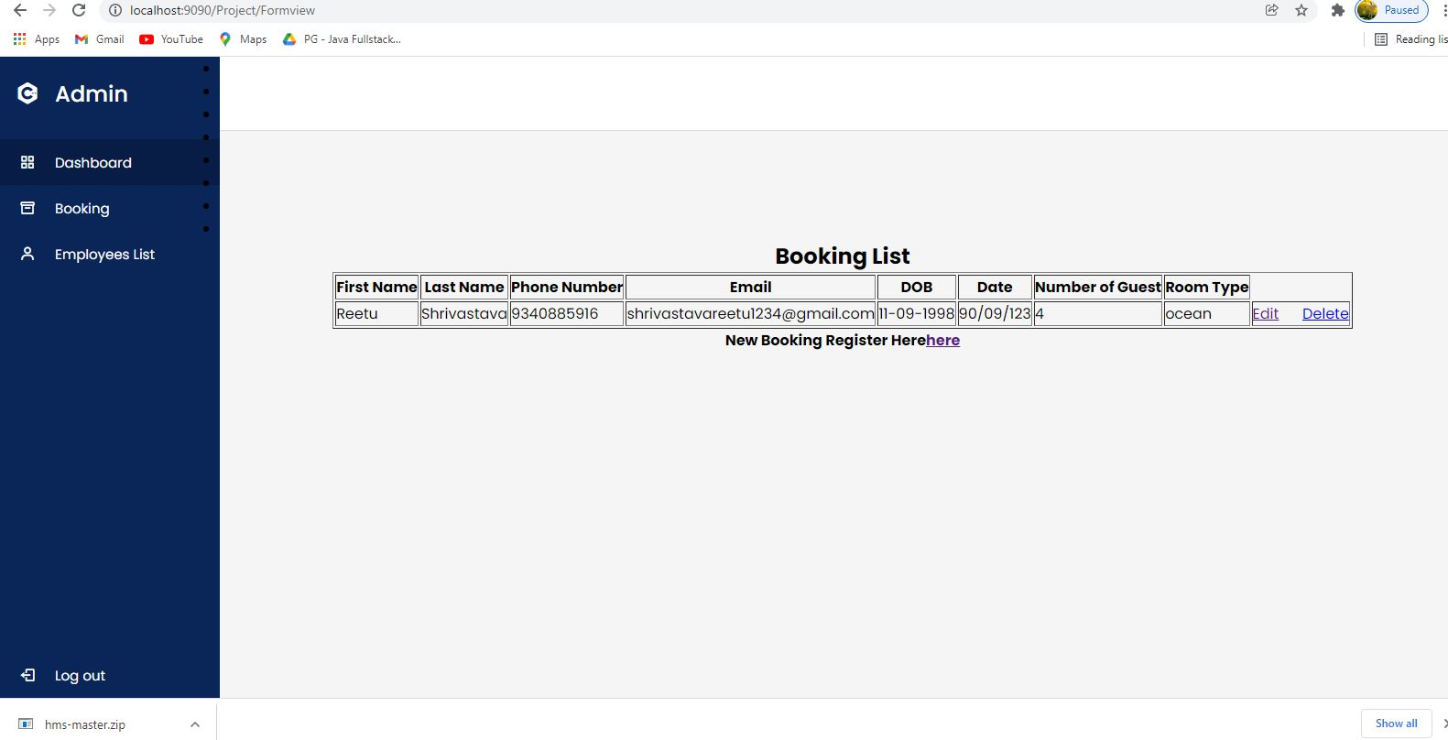

**Successful Booking List Done:**

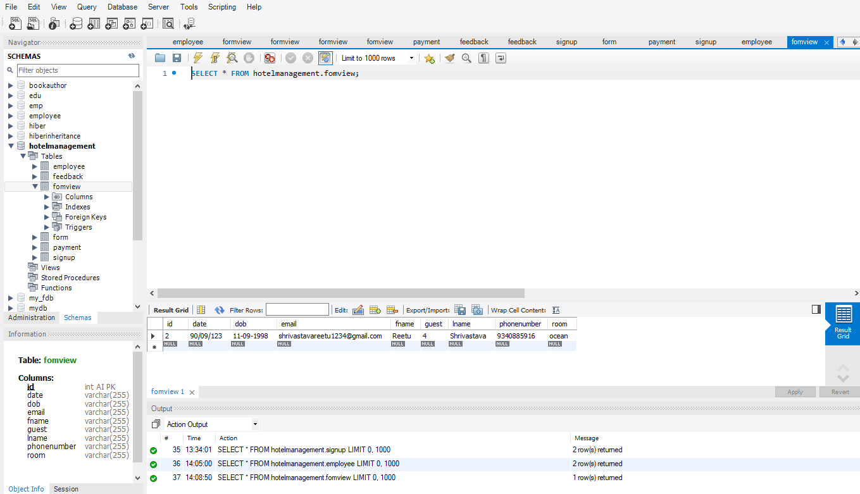

**Employee Data by Admin:**

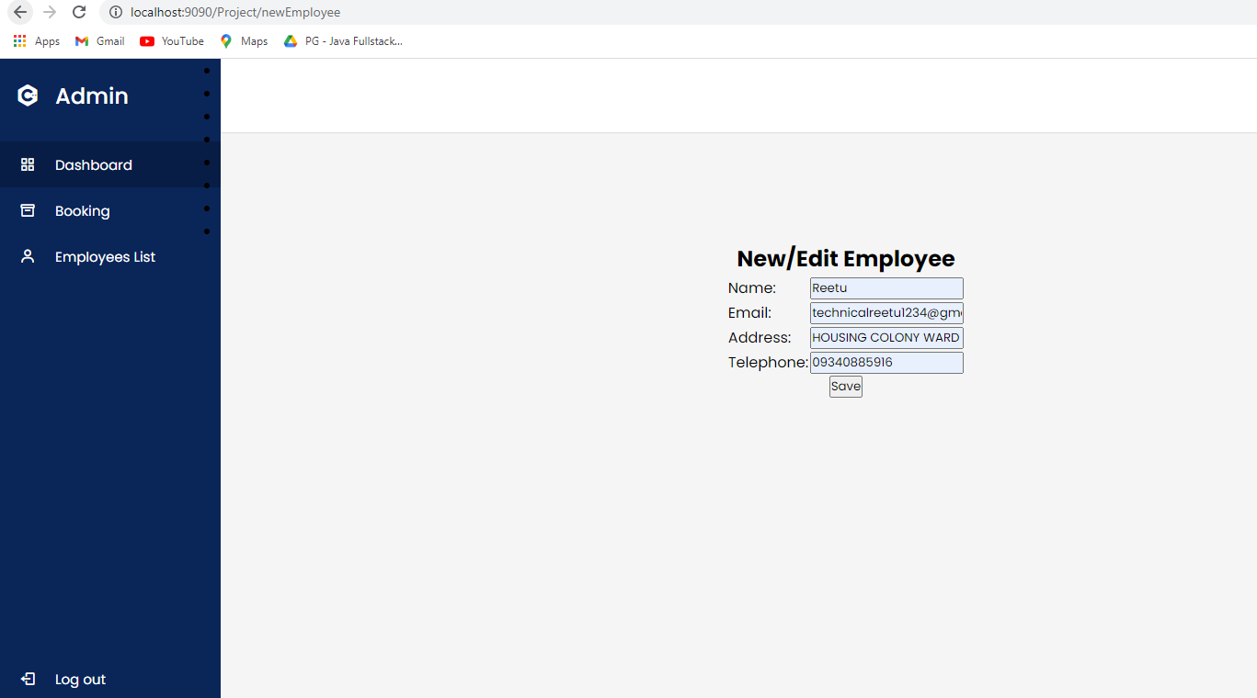

**Employee List:**

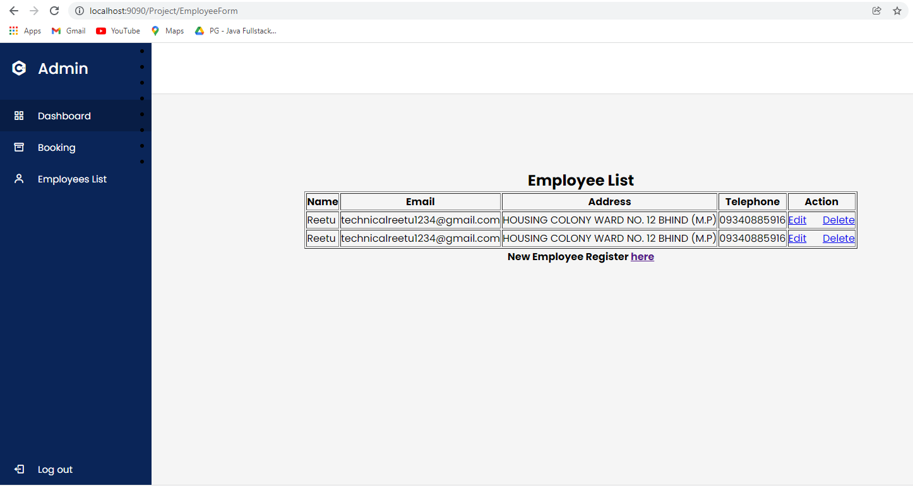

**Successful Booking List Done:**

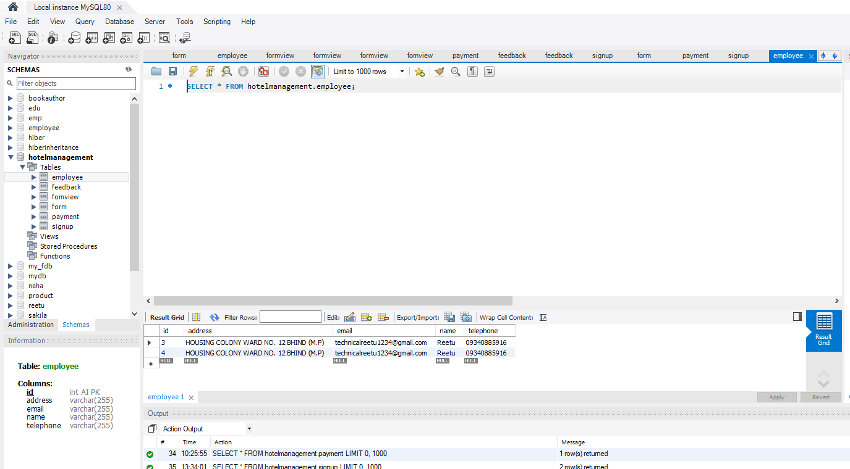

**About Us:**

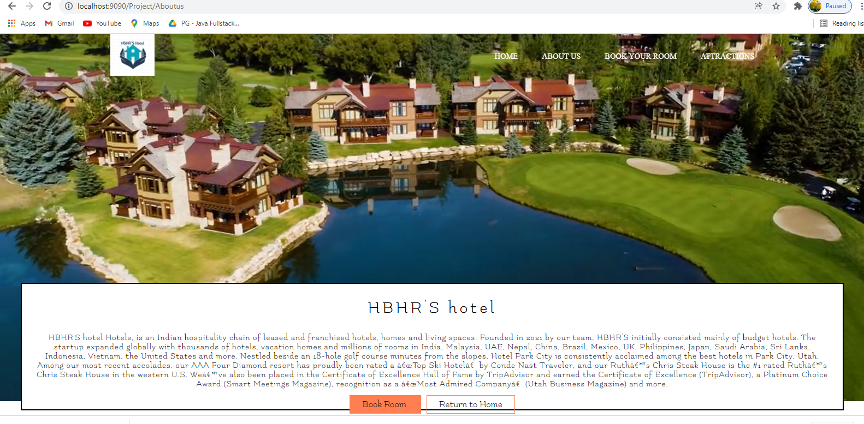

**Attraction :**In attractions page the user can see the different types of rooms as images for getting better idea of how the rooms appearance.

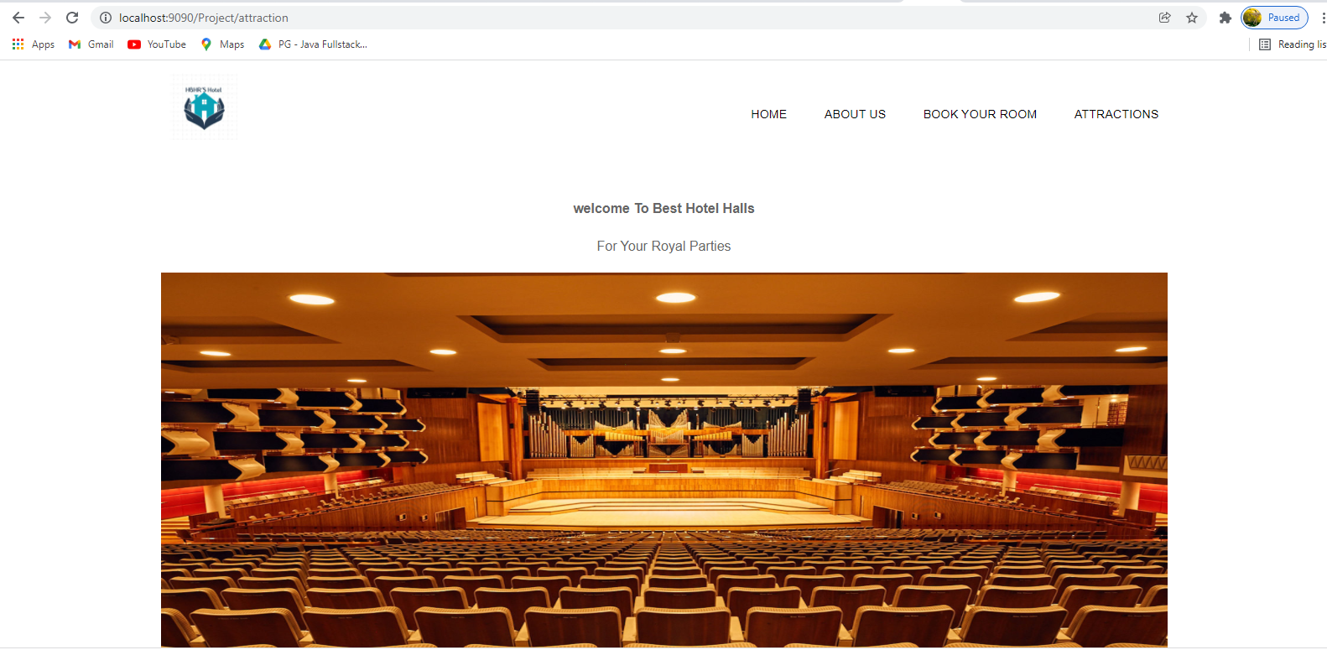

**Booking Form Data:**

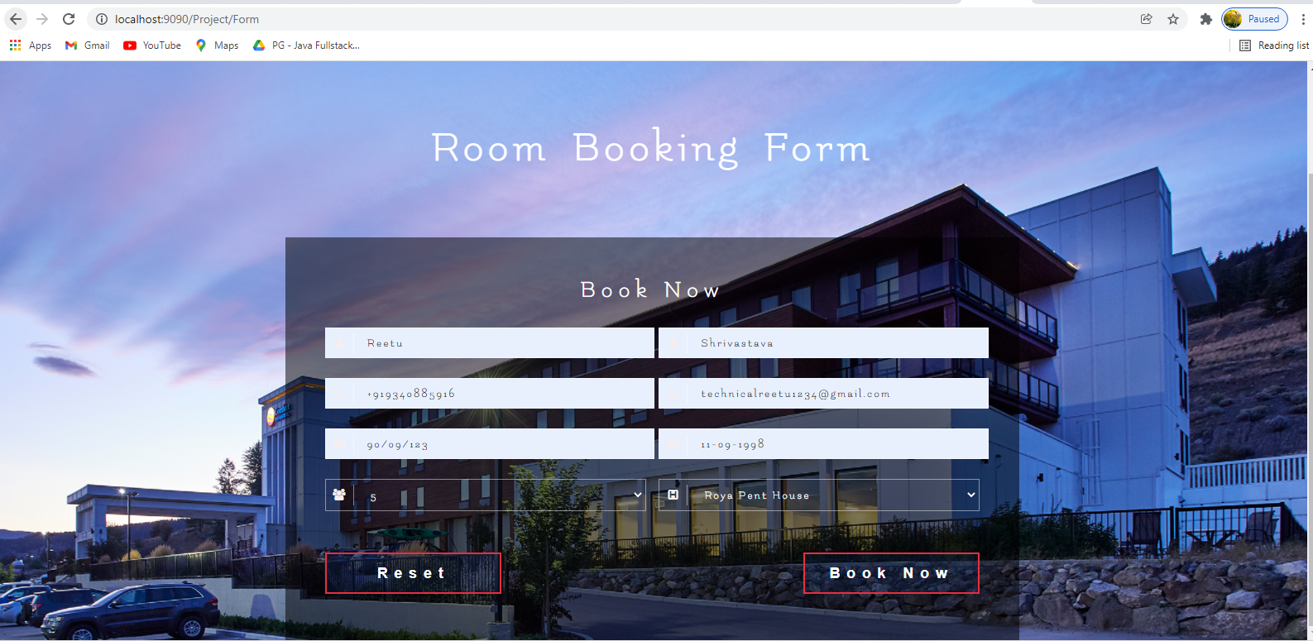

**Successful Booking :**

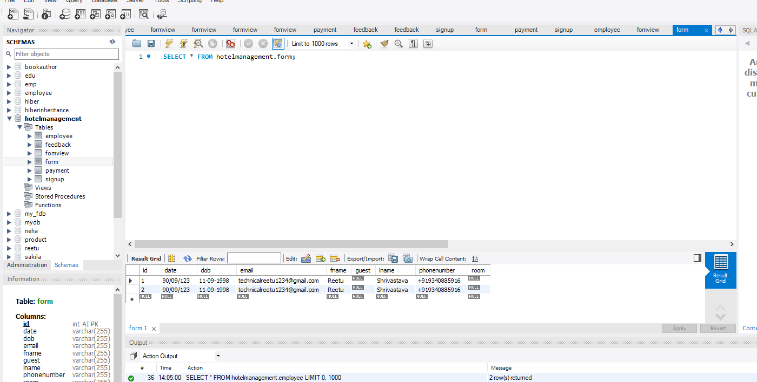

**Payment Form:**

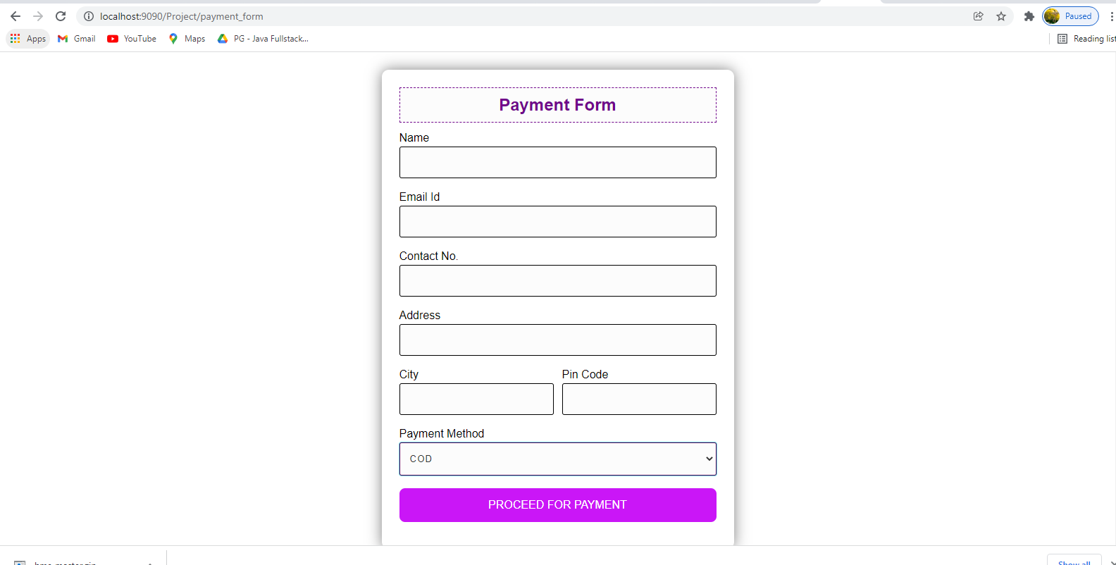

**Payment Form with Data:**

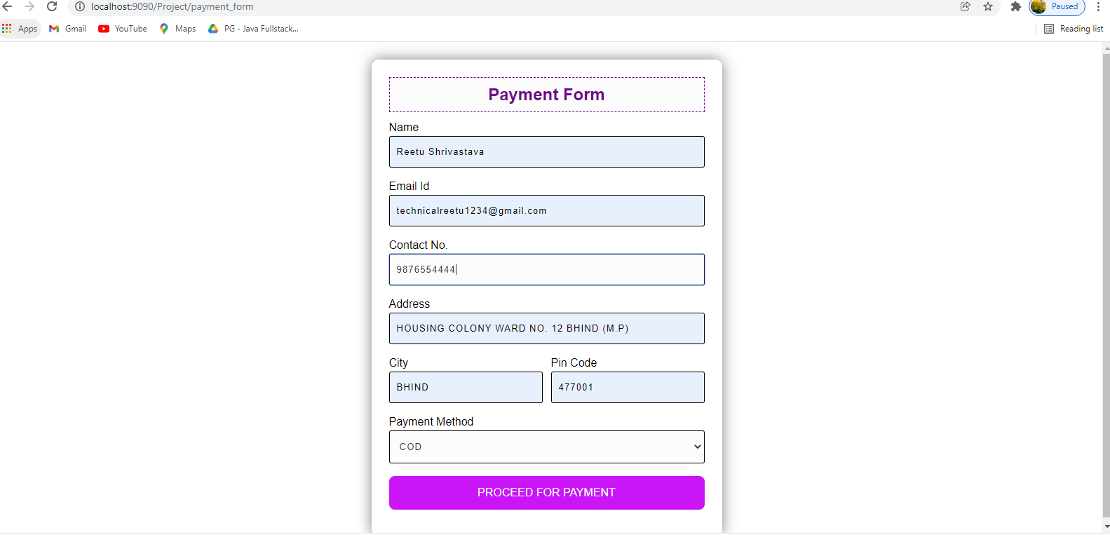

**Successful Payment Done:**

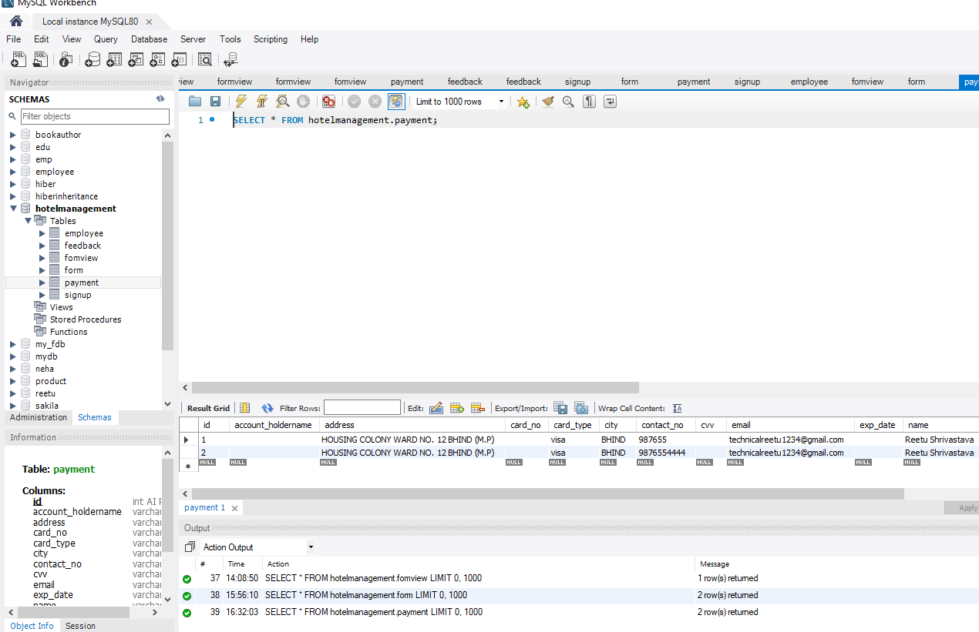

**Thank you**